Lab Manual

**OOP**

**Laboratory 01: Introduction to Running Simple Programs in Java**

**Lab Objectives:** After this lab, the students should be able to

1. Install JDK
2. Run simple Java Programs

**Software Development Kit (SDK)** that contains the following:

**Libraries**: also known as Application Programming Interface (API), these files are previously written classes and methods that contain some common functionality.

**Compiler**: the program that translates files written in Java language (human language) into binary files (machine language) in order to execute them.

**Interpreter**: Some programming languages do not compile the source code file into directly executable form (native code), but they instead compile it into partially compiled file that could be executed by a program called interpreter.

**Java Programming Language:**

Java programming language is an interpreted programming language, that is, when the source code is compiled into binary file, it needs an interpreter called Java Virtual Machine (JVM) to run it. Java compiler is called **javac.exe**, and interpreter is called **java.exe**.

The Figure below shows a complete path of running Java programs.

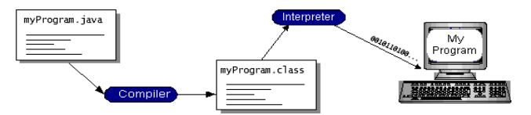

1. **JDK INSTALLATION:**

For compiling and running java programs we need to install **JDK**.

A JDK distribution consists of a JRE distribution (a Java Virtual Machine implementation) plus a collection of development tools including javac :a Java compiler, and javadoc: Java documentation generator.

**DOWNLOADING JDK 7:**

Follow the steps for downloading jdk from net.

* Go to this link and download JDK 1.7.0.

<http://www.oracle.com/technetwork/java/javase/downloads/index.html>

* Click on the Java Download icon.
* Following window will appear on your screen. Check the accept license option and click on the highlighted version to download jdk.

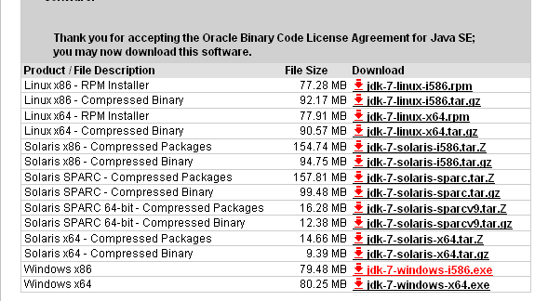

* After downloading double click the jdk icon to start installation process.

**INSTALLATION STEPS:**

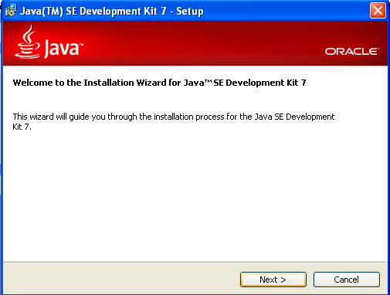

* Click NEXT to move ahead.

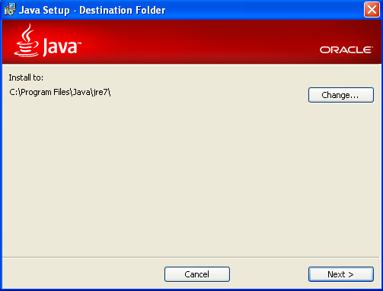

* Click NEXT
* Now JRE will start installing.

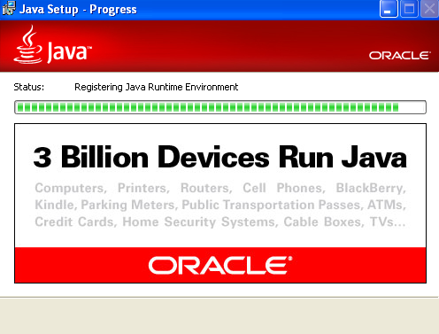

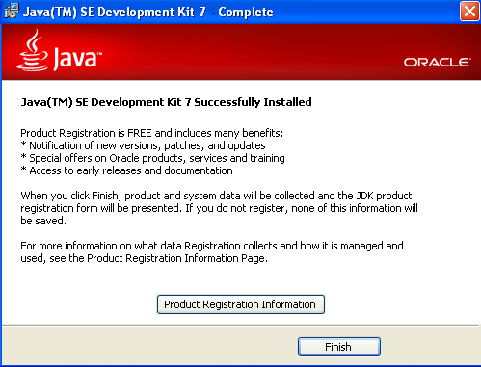

* Click Finish to end installation process.
* Now you can create, compile and run java programs.

**Note:** For Lab, JDK 7 or JDK 8 will be provided to you to install in the system.

**2. CREATING A SIMPLE JAVA PROGRAM:**

* Open up an editor (notepad) and write the following code.

|  |
| --- |
| class Uet  {  public static void main(String abc[])  {  System.out.println("My first Java Program");  }  } |

* Save the program in C:\program Files\java\jdk1.7.0_76\bin with the name Uet (same as the name of class) and Extension (.java) i.e.; Uet.java.
* In order to compile and run the program do the following

Start -> Run ->(type) cmd ->(press Ok).

* Then in command prompt write the following.

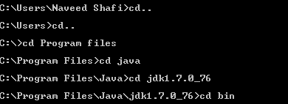

This is done to change the directory to the drive where bin of java is installed.

cd is a command used for changing directory.

* Now compile the program on command prompt as:



The command javac converts the java source code into byte code program.

* Assuming your program contains no errors, the compiler generates a byte code program that is equivalent of your source code. The compiler stores the byte code program in a file with the same name as source file, but with the extension .class.
* To execute the byte code program in the .class file with the java interpreter in the JDK, you enter the command



* If there is no exception in the program the output is printed on the command prompt.



**LAB TASKS:**

**Task 1:**

**Run the following codes and see the result.**

Run the following programs. Observe the output. Focus on comments to enhance the understandability.

**Program # 1**

|  |
| --- |
| class Program1{  ***//your program begins with a call to main().***  public static void main (String args[] )  {  System.out.println(“ Welcome to java world !”); ***//println() displays the string which is passed to it.***  }  } |
|
|
|
|
|
|
|
|
|
|

**Program # 2**

|  |
| --- |
| class Program2 {  public static void main(String args[]) {  int a,b,c; ***//this statement declares three variables a, b and c.***  a=2;  b=3;  c=a+b;  System.out.println("Sum of two numbers = "+c); }  } |
|
|
|
|
|
|
|
|
|
|

**Task 2:**

**Run the following code by saving it firstly with name abc.java and then with bcd.java and check the output.**

class abc

{

public static void main(String args[])

{

System.out.println(“hello world!”);

}

}

class bcd

{

public static void main(String args[])

{

System.out.println(“This is my First Program!”);

}

}